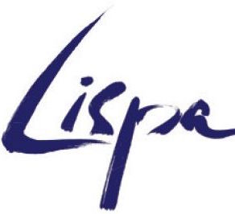
2018/2019 Workshop Intensives in Berlin
Application form

Name
Address
Nationality
Age on 01 Oct 2018
Email

Please select all workshops which you are applying for:
Intensive I - Embodied Wisdom- all 5 weeks | 08 October - 09 November 2018 | 1850€ | ▢
Intensive I - Workshop I: The Playful Body | 08 - 12 October 2018 | 350€ | ▢
Intensive I - Workshop II: The Poetique Body | 15 - 26 October 2018 | 700€ | ▢
Intensive I - Workshop III: The Mythic Body | 29 October - 09 November 2018 | 800€ | ▢
Intensive II - Masked Play - all 5 weeks | 12 November - 13 December 2018 | 1750€ | ▢
Intensive II - Workshop I: Larval Masks | 12 - 16 November 2018 | 350€ | ▢
Intensive II - Workshop II: Expressive Masks | 19 Nov - 30 November 2018 | 700€ | ▢
Intensive II - Workshop III: Half Masks | 03 December - Thurs 13 Dec 2018 | 700€ | ▢
Intensive III - Night Sea Journeys - 11 weeks | 01 October - 14 December 2018 | 4400€ | ▢
Intensive IV - The Poetics of Disorder - 8 weeks | 07 January 2019 - 01 March 2019 | 3200€ | ▢
Intensive IV - Workshop I: Theatre of the Grotesque | 07 January 2019 - 01 February 2019 | 1600€ | ▢
Intensive IV - Workshop II: Clown and Comical Worlds | 04 February 2019 - 01 March 2019 | 1600€ | ▢

How did you hear about this workshop series? (Please tick or highlight all that apply)
□ An email from LISPA □ Facebook  □ From a present or former LISPA student | □ Google/Search engine  □ Other (please state) ………………………………..
Please scan this completed form and attach a CV of relevant experience, a short statement of interest and a recent photograph, and email everything to the school at welcome@lispa.co.uk.

We no longer accept applications by post!

Once you have received from us an offer of a place on the workshop/s, you must make a full payment to secure your place - please wait for confirmation of your offer before making a payment. Non-payment of course fees may result in your place being offered to someone else. Note also that since our workshops are always heavily oversubscribed, all payments are non-refundable. Reimbursements or partial reimbursements are sometimes possible in individual cases only if we are able to fill your cancelled place with someone else from our waiting list.

All fees are in Euros and LISPA uses an online payment tracking system at flywire.com. Full details will be sent to you with your offer of a place on the course.

